# INTRODUCTION

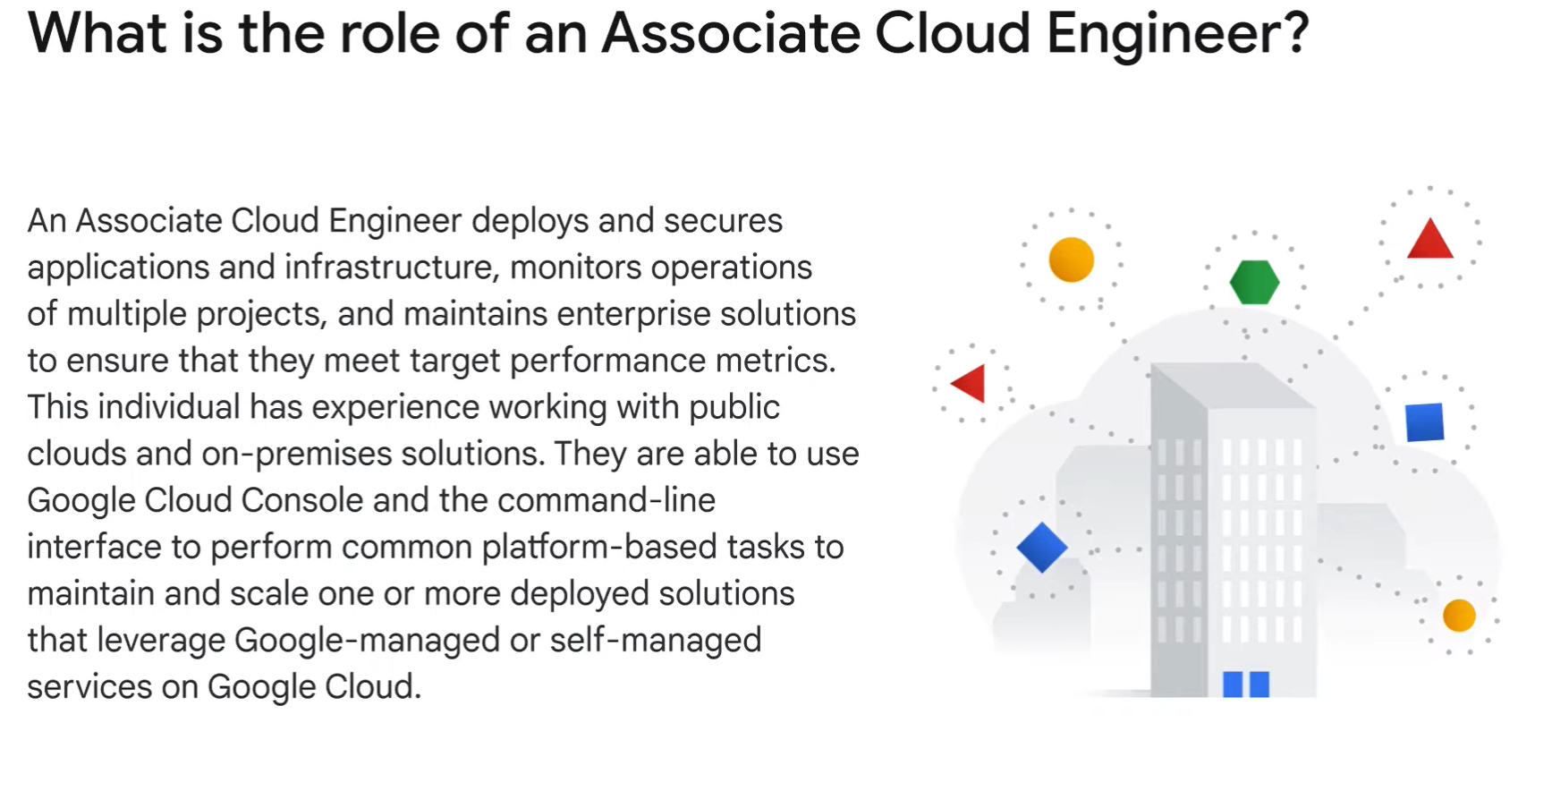

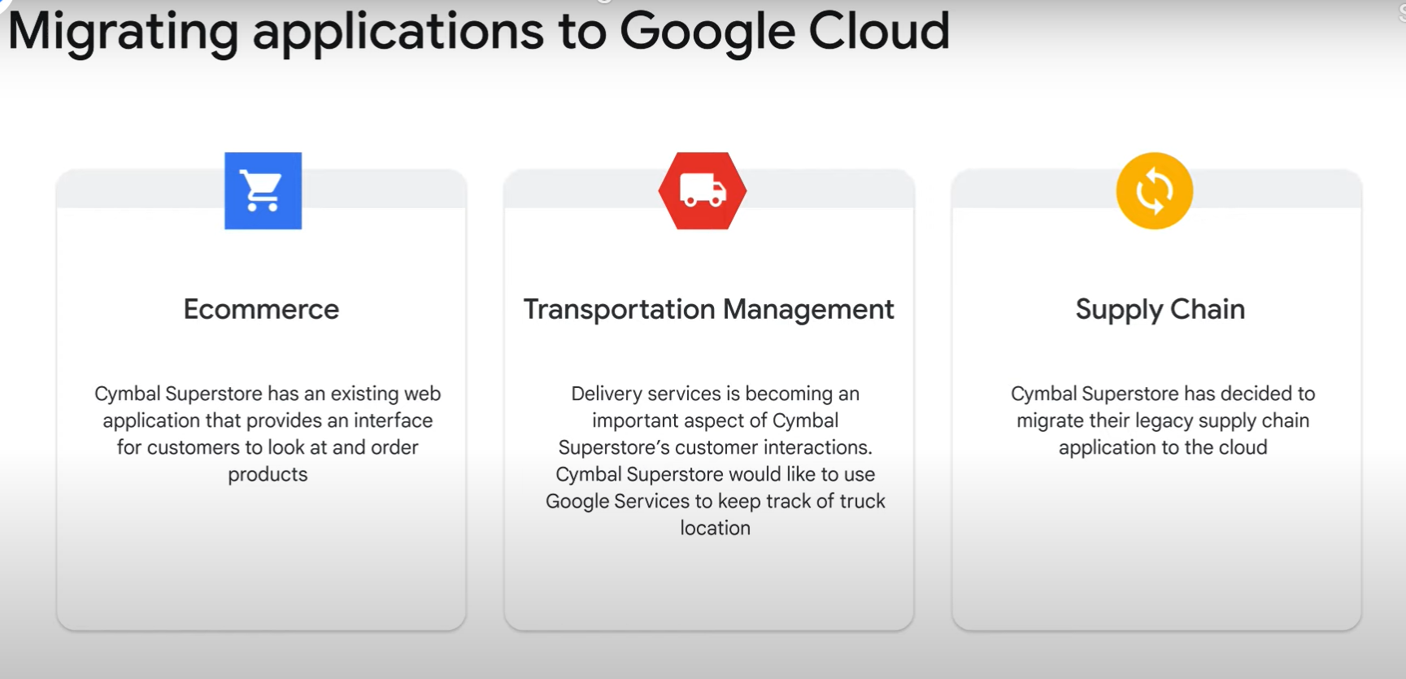

## Setting Up a Cloud Solution Environment:

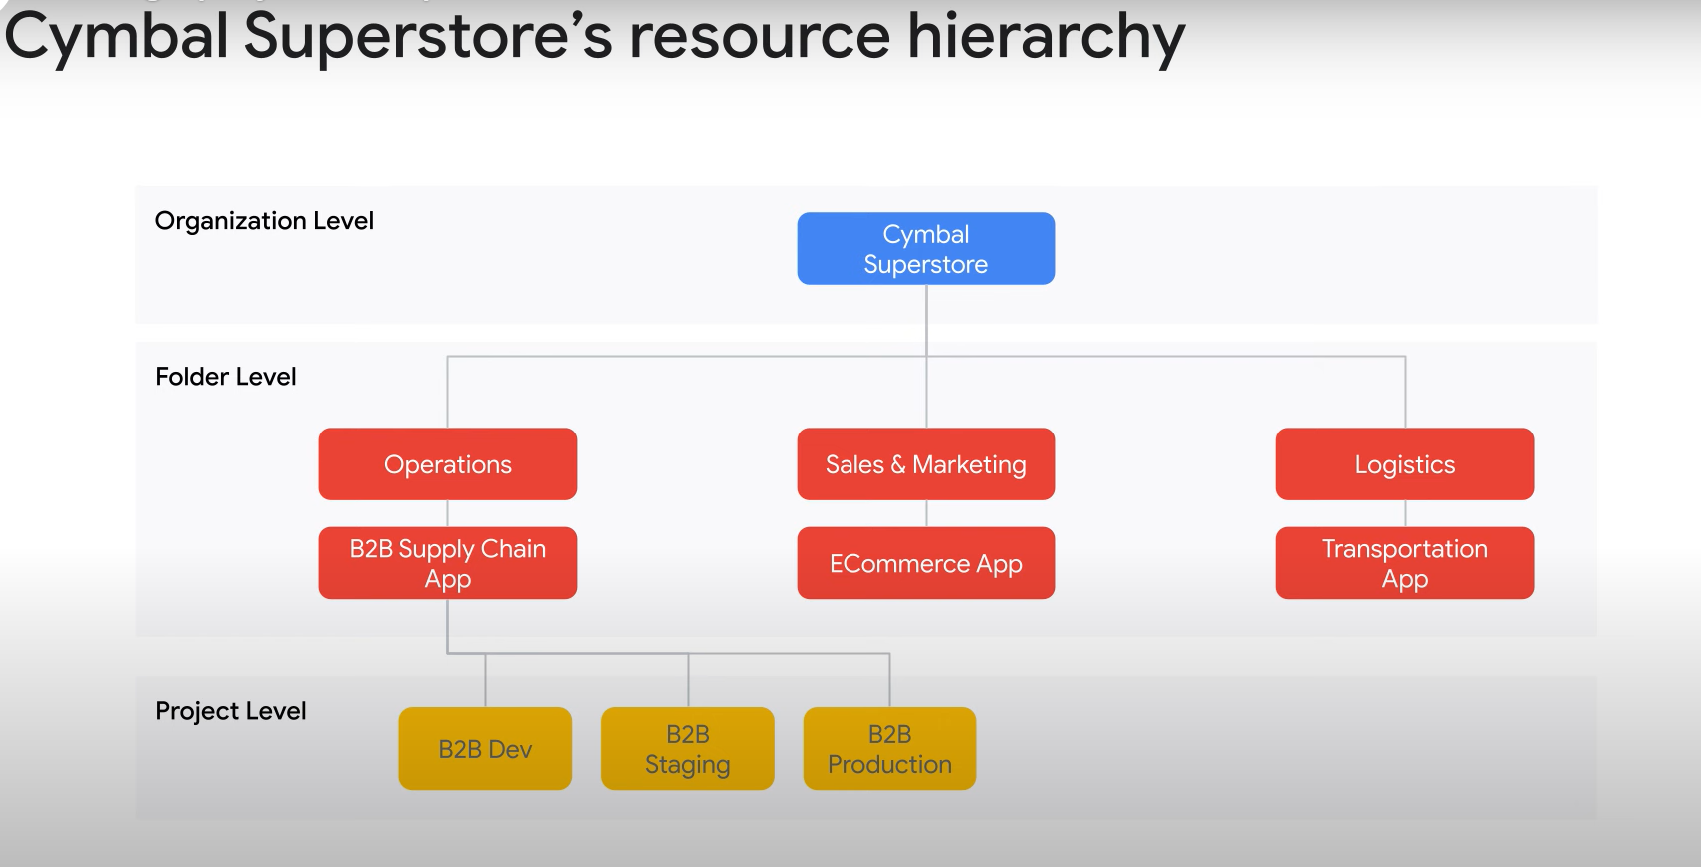

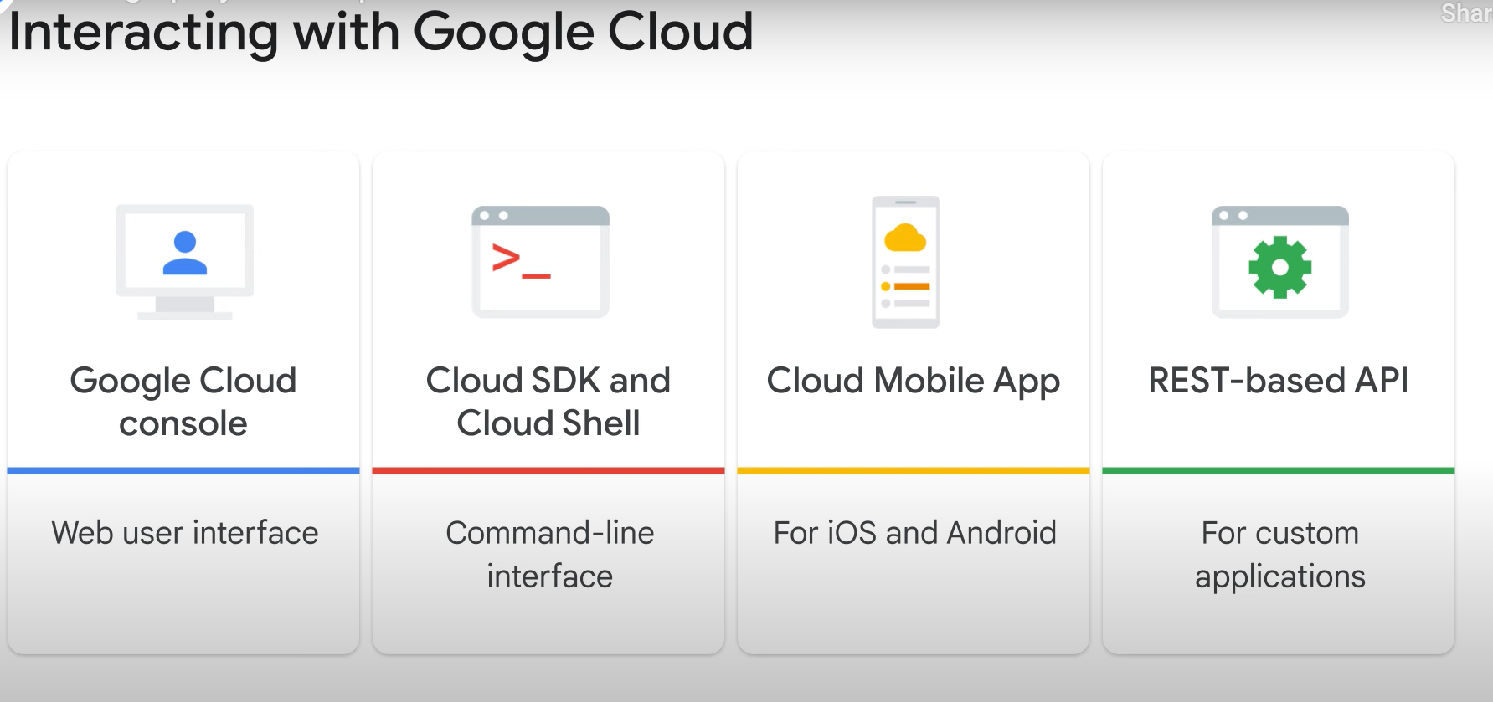

## Planning and Configuring a Cloud Solution

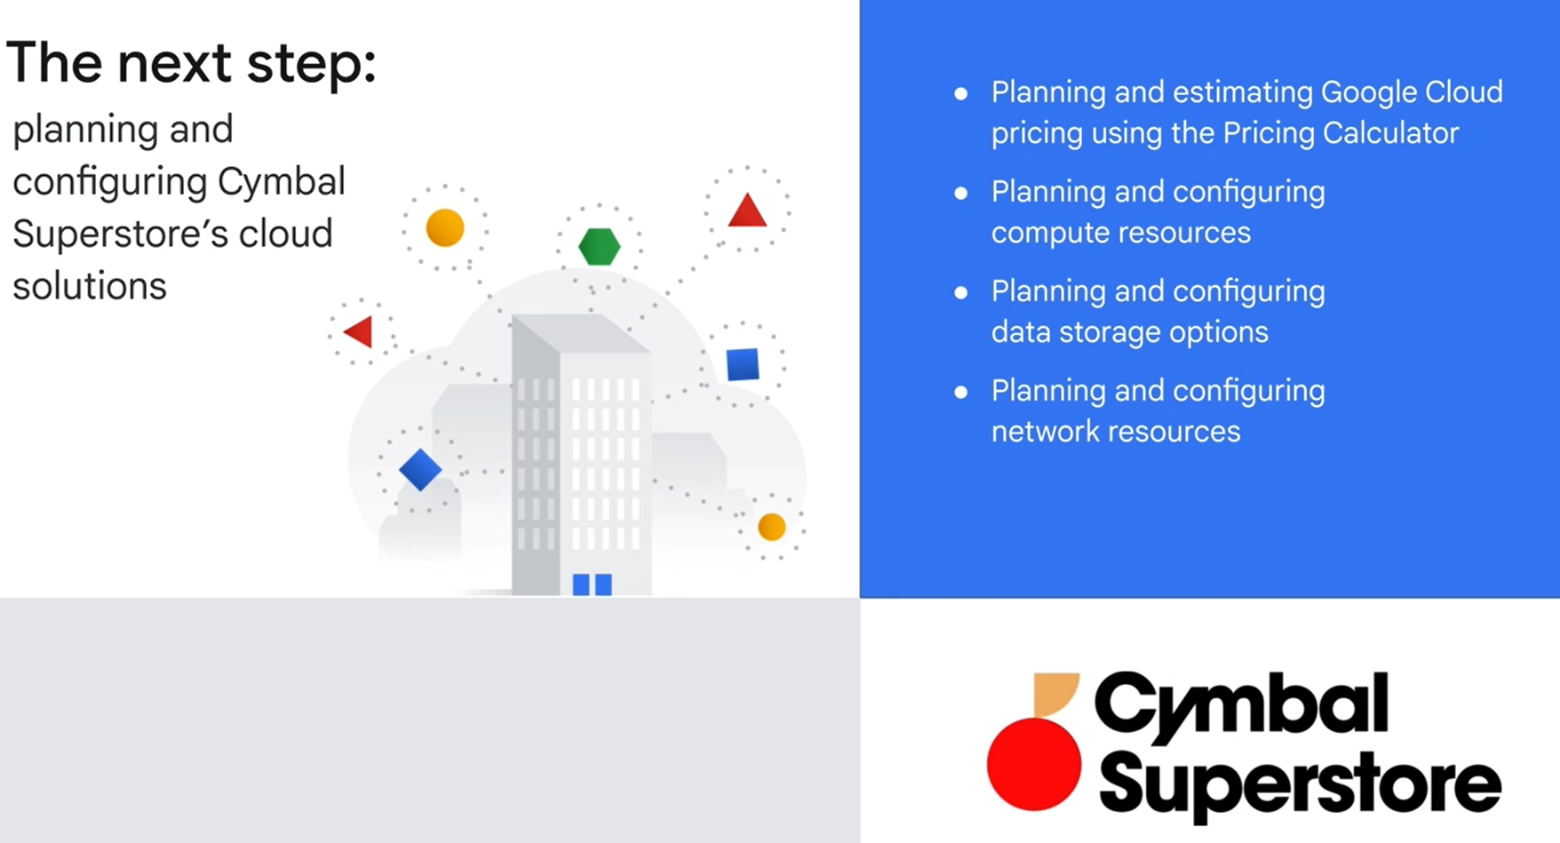

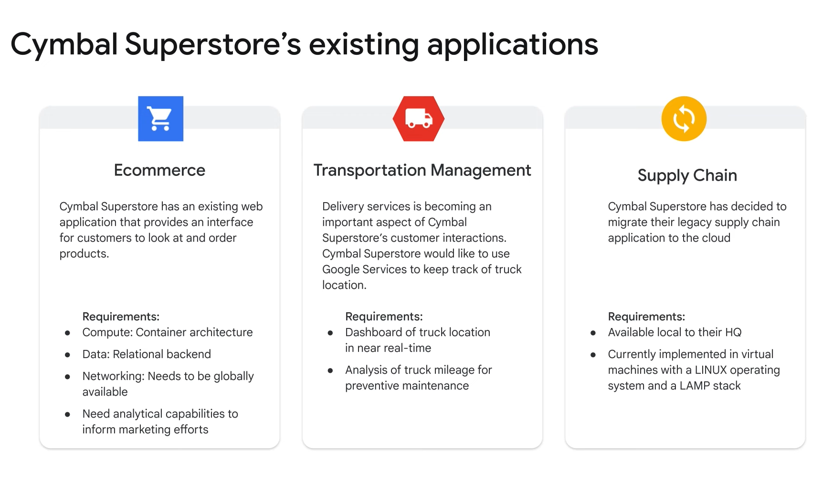

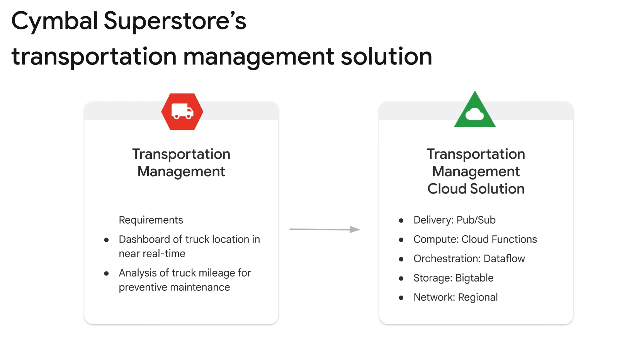

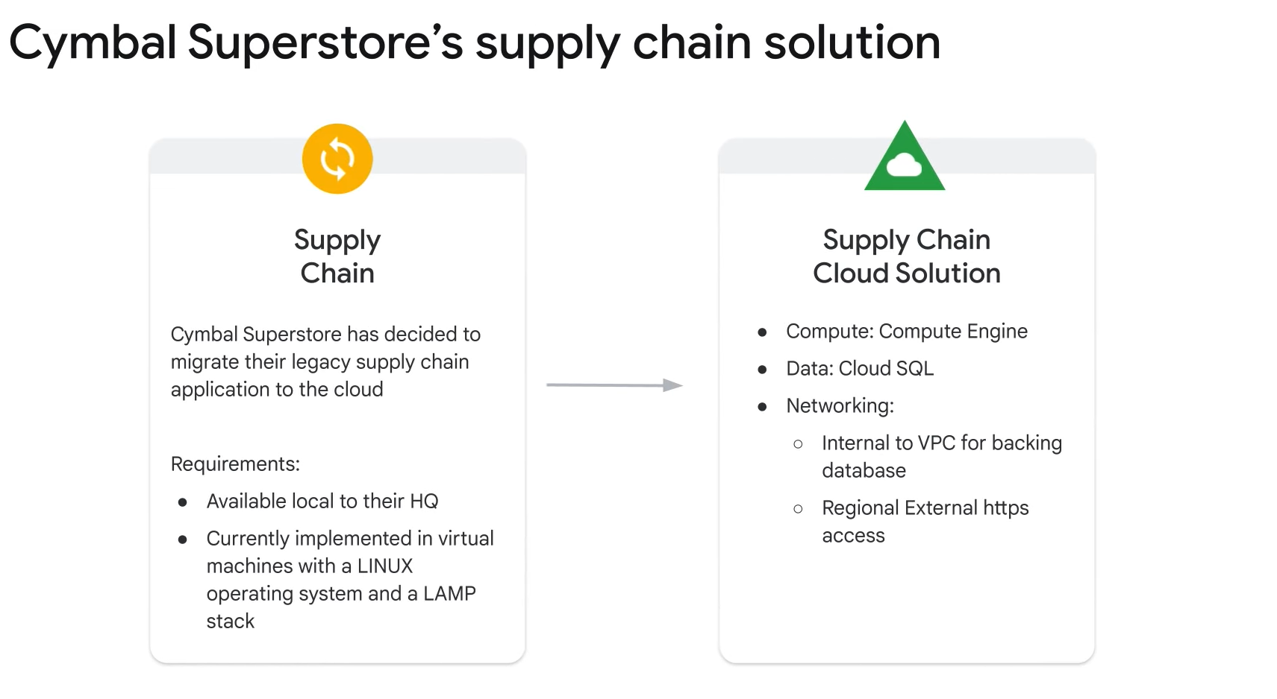

## Deploying and Implementing a Cloud Solution:

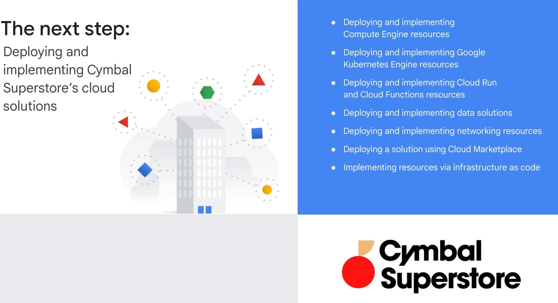

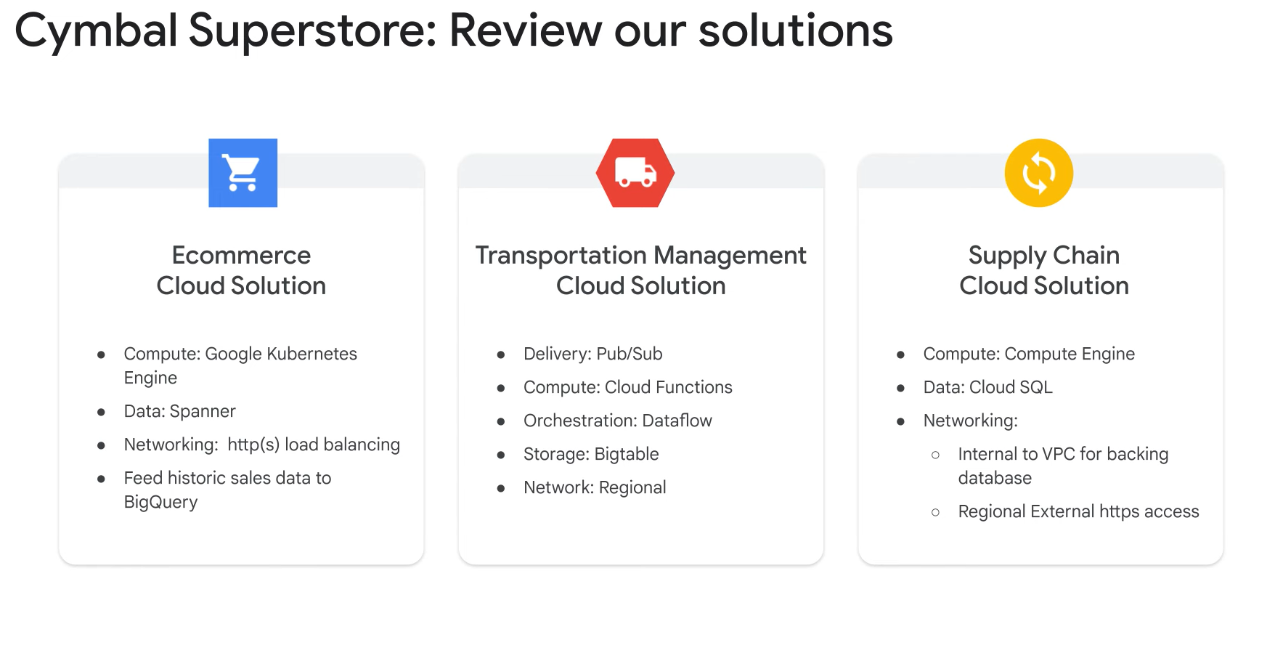

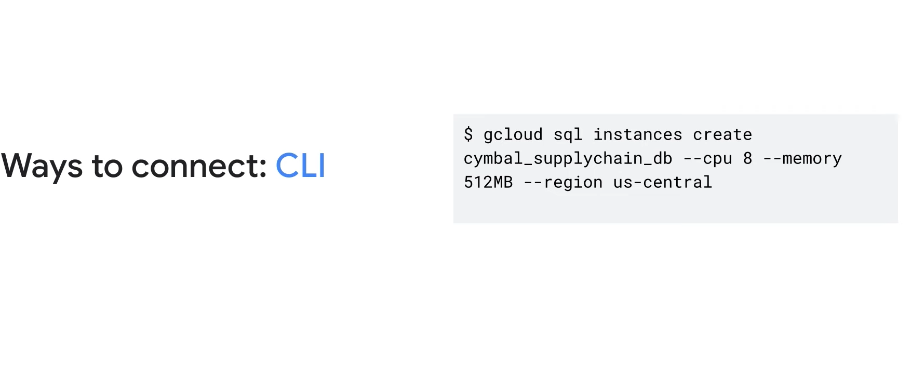

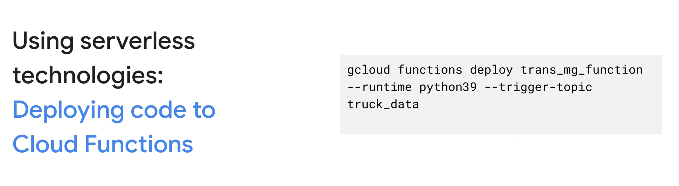

## Ensuring Successful Operation of a Cloud Solution:

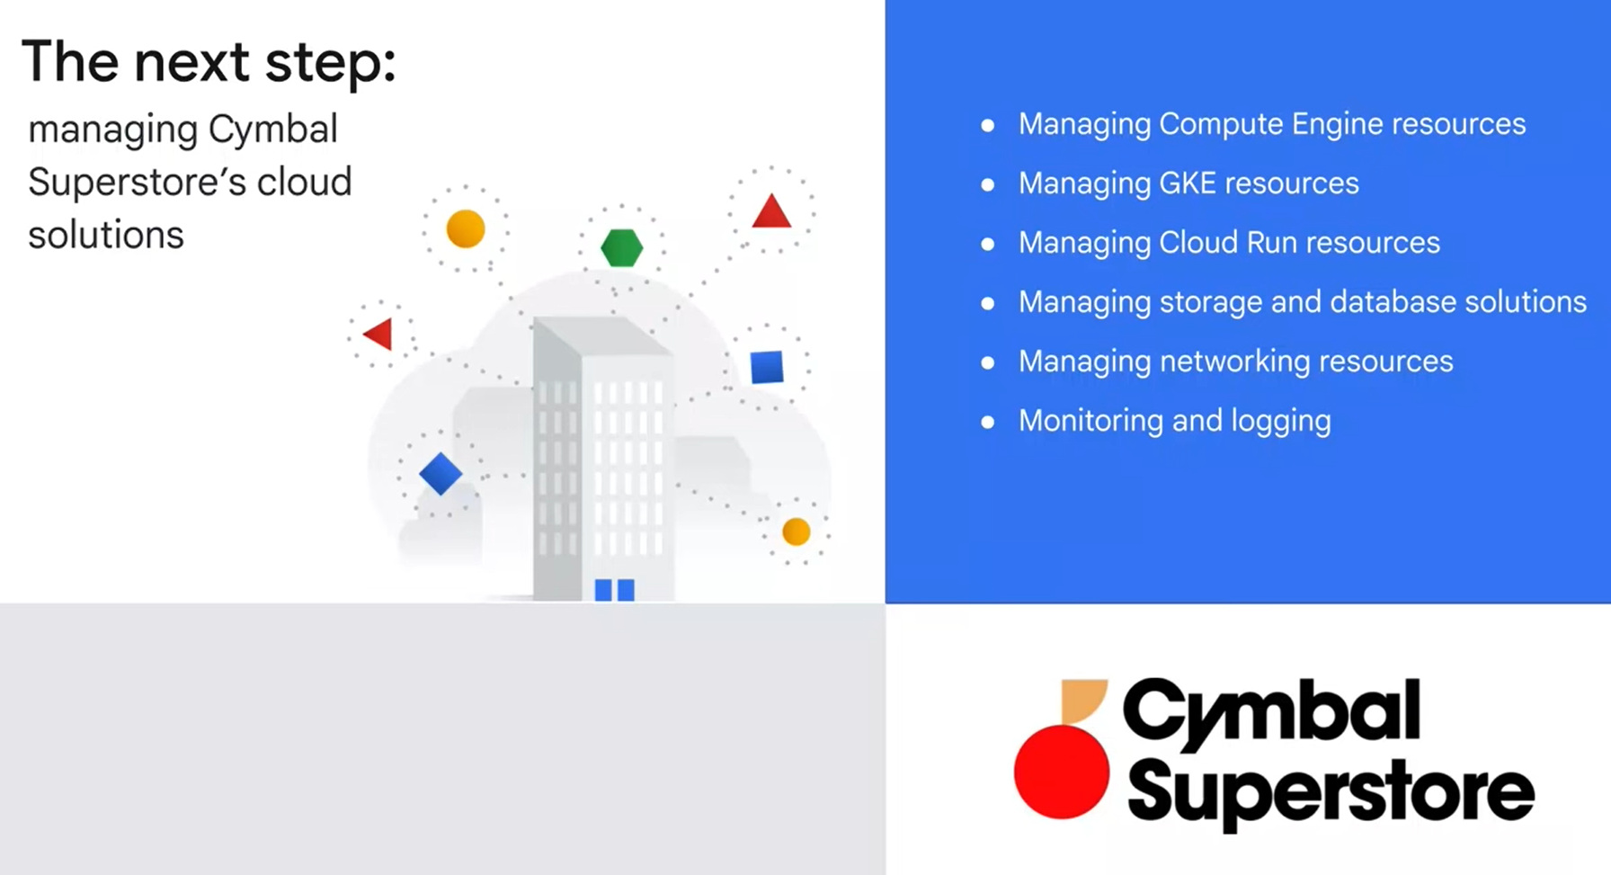

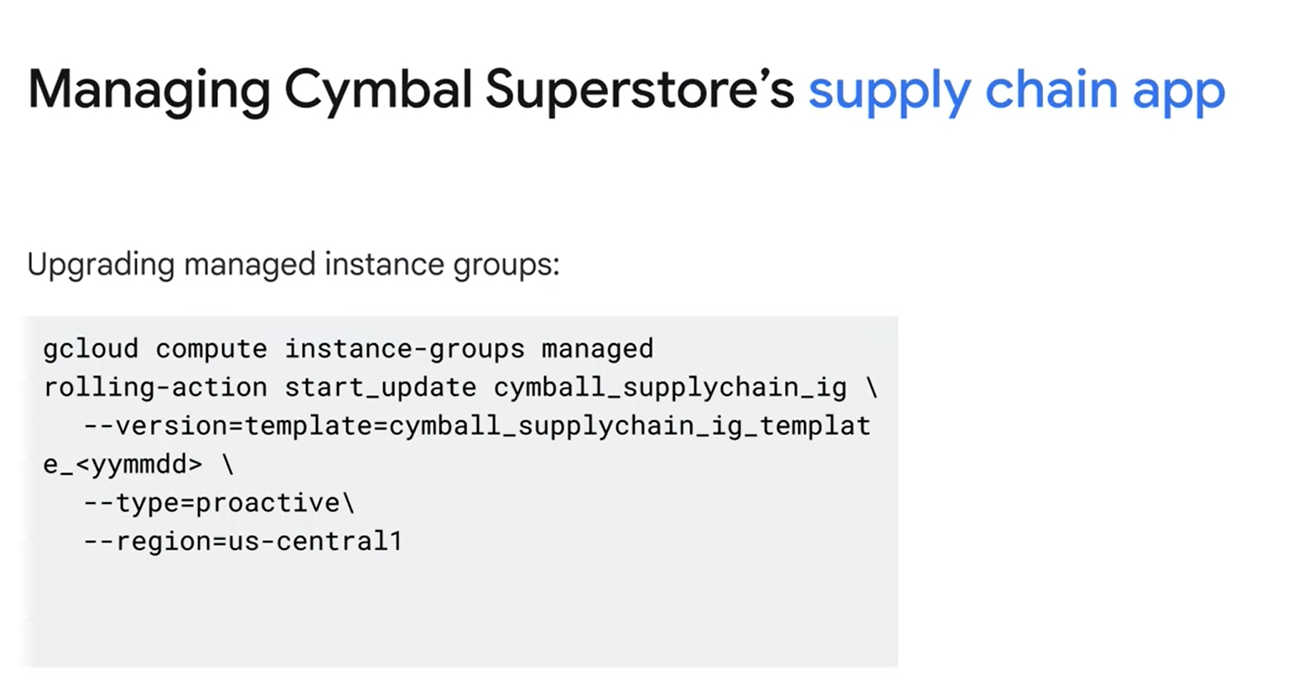

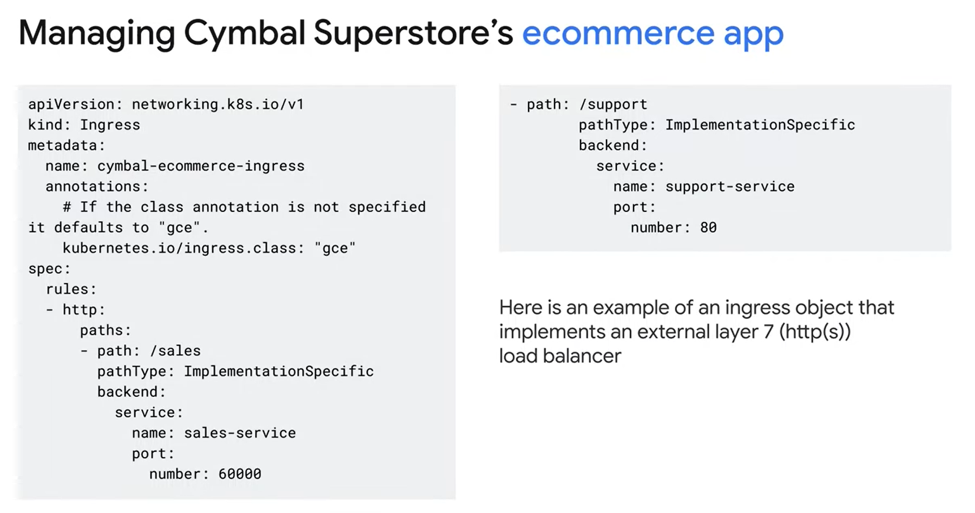

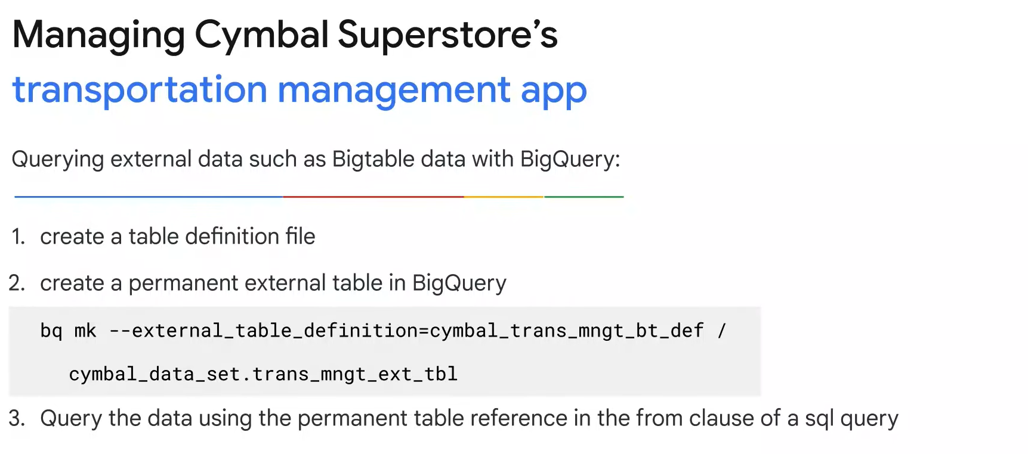

## Configuring Access and Security:

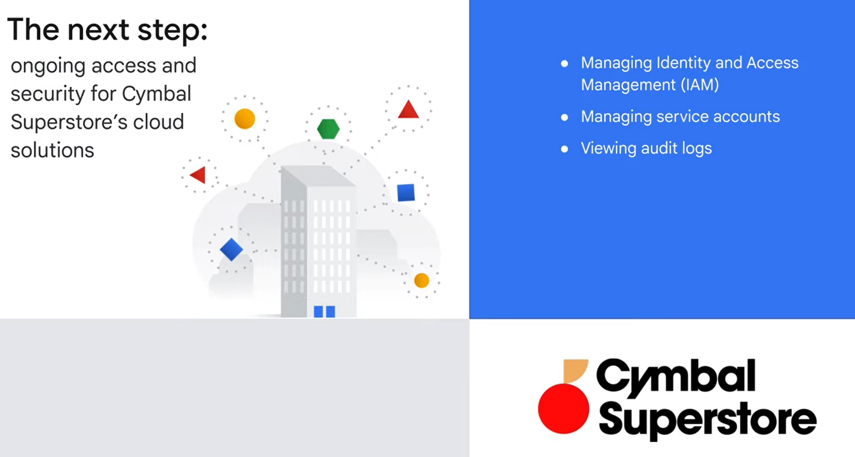

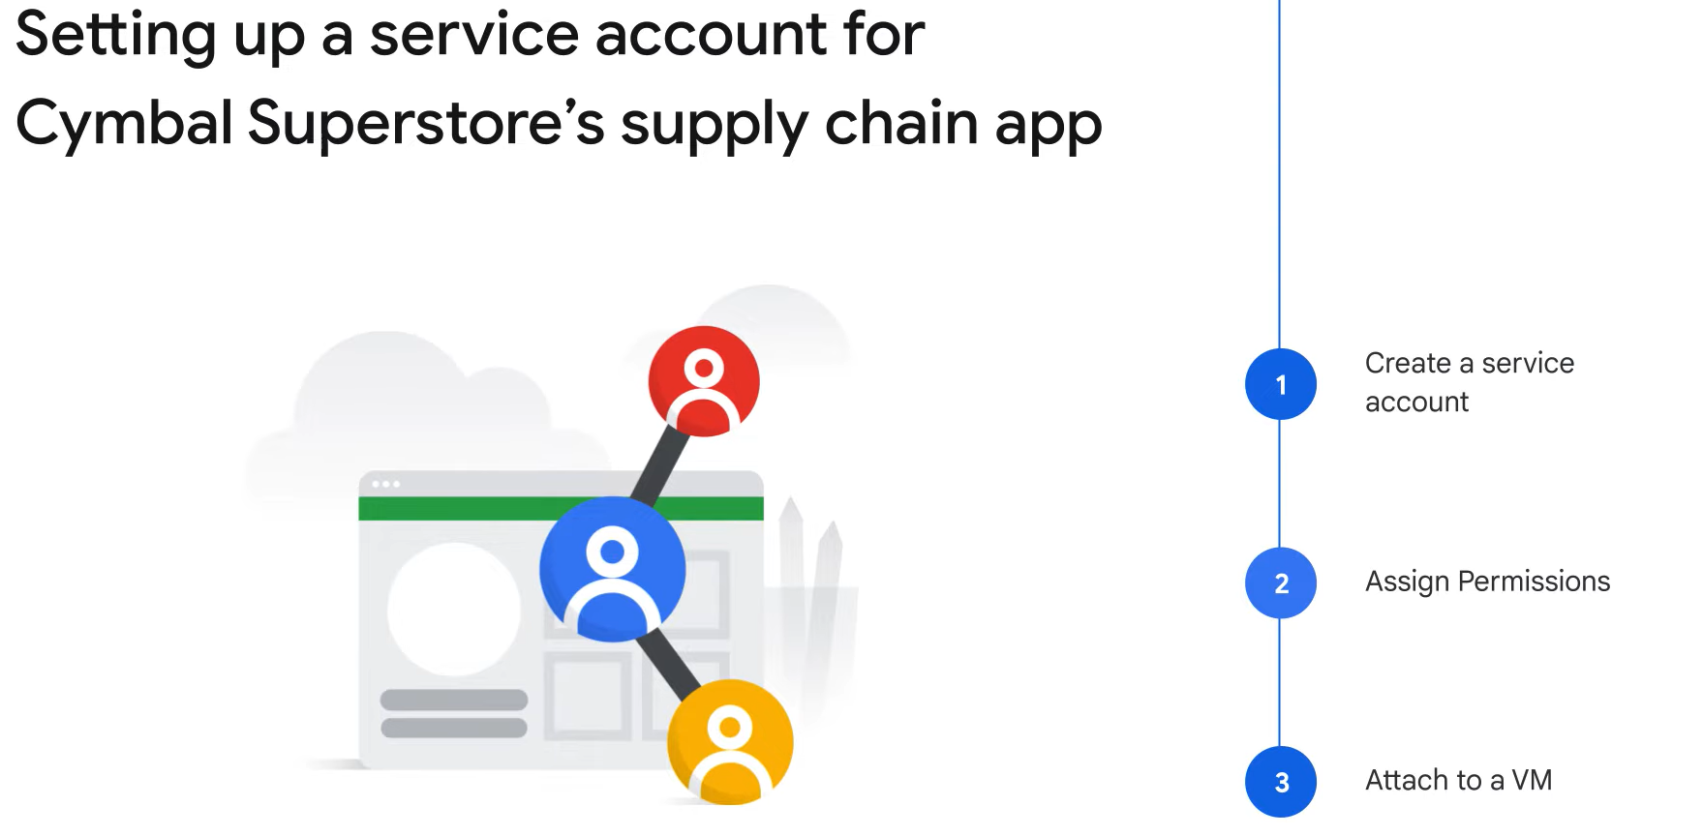

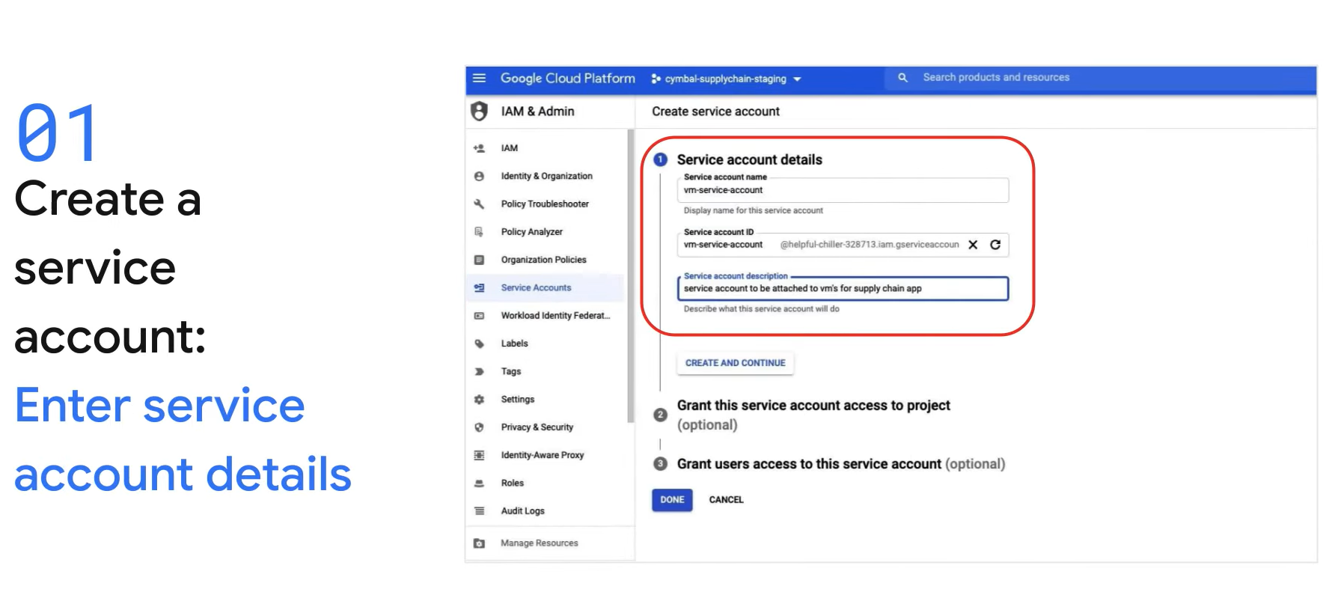

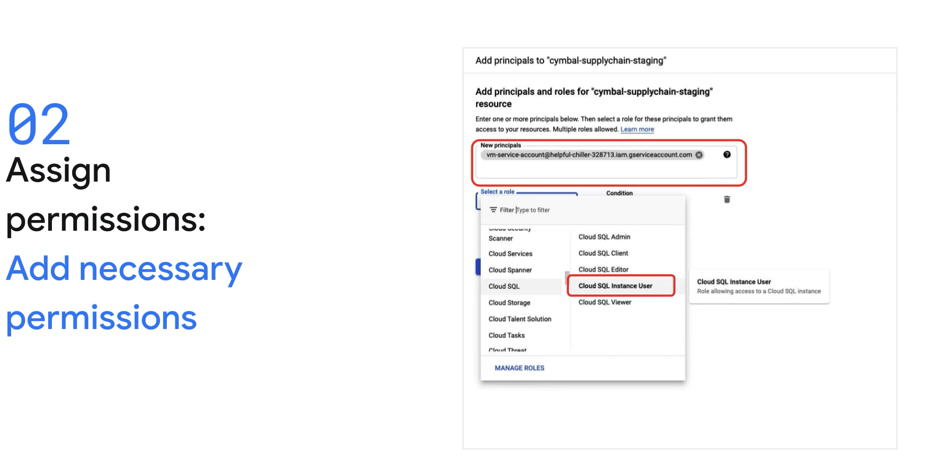

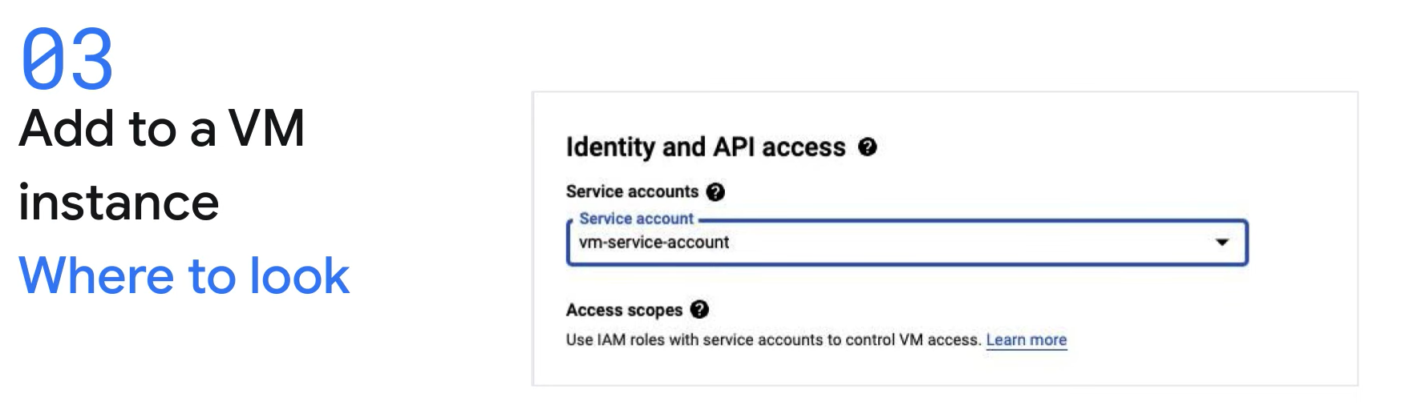

## Next Step:

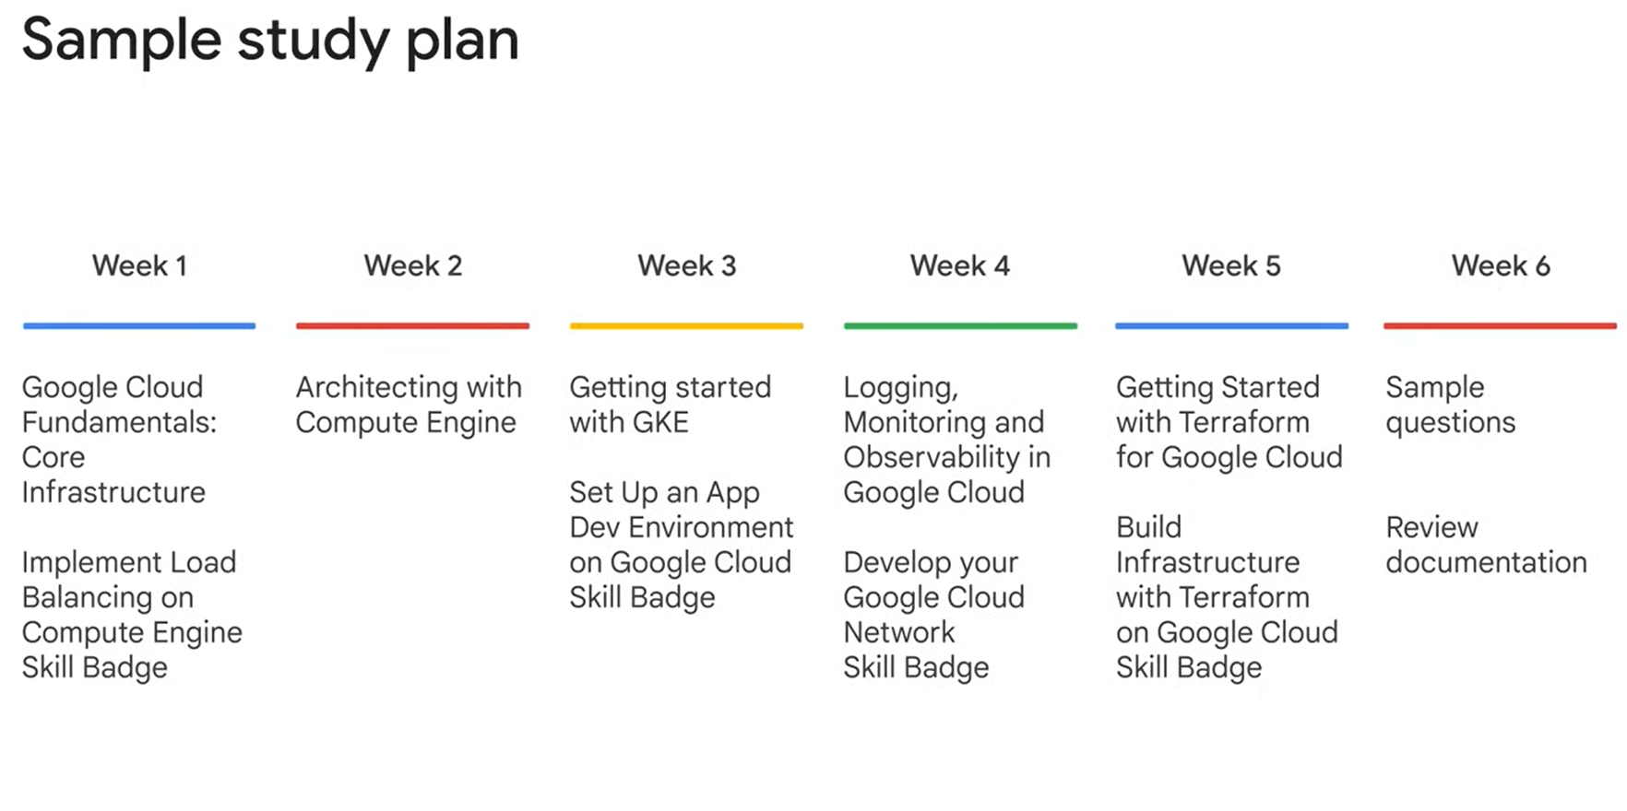

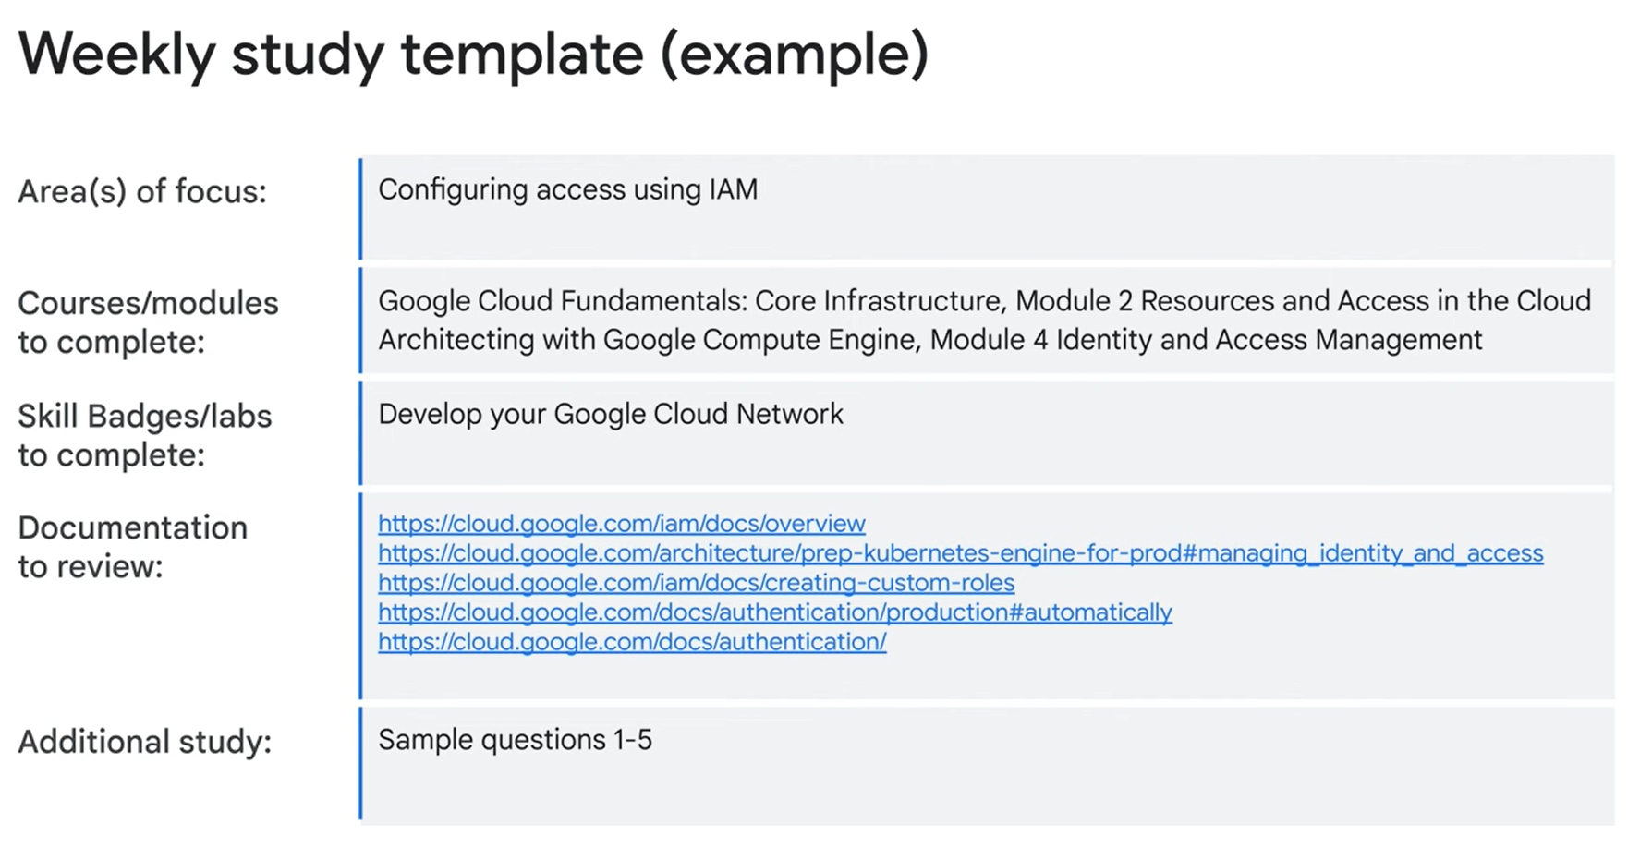

# Core Infrastructure

## Interacting with Google Cloud

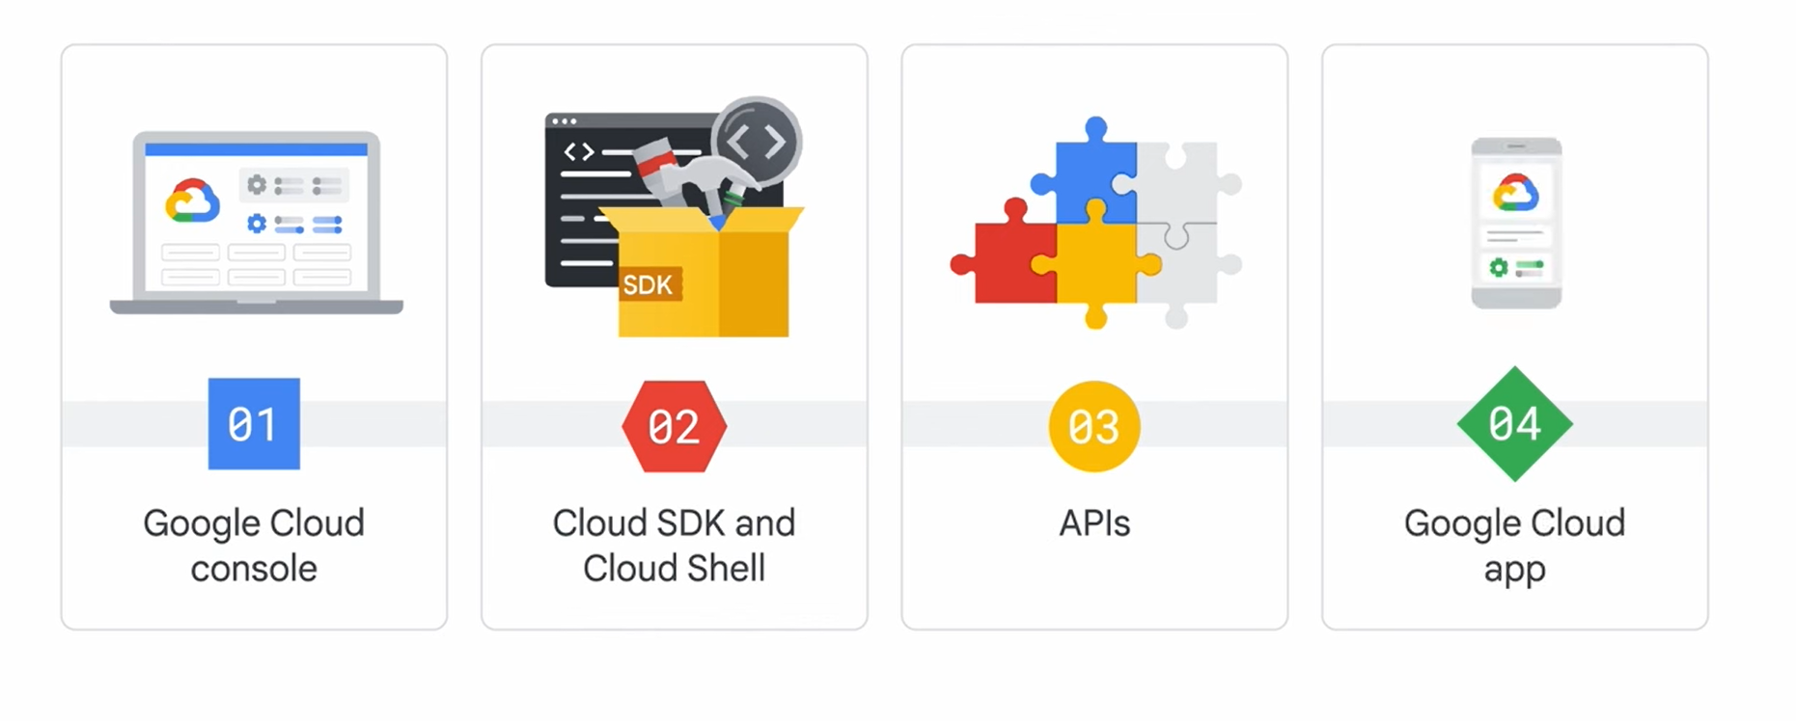

Cloud:

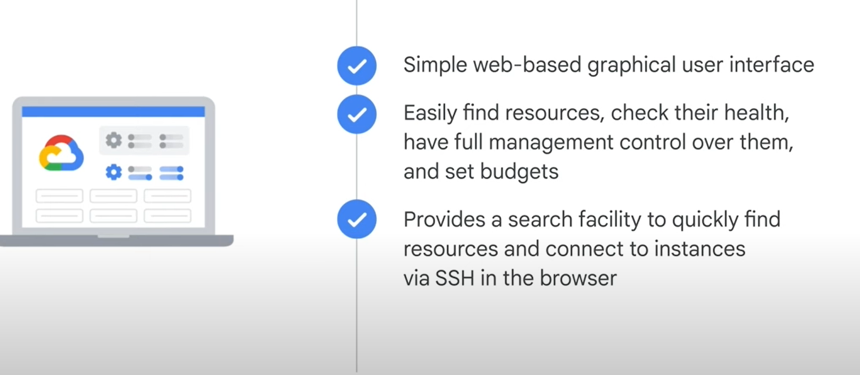

Sdk:

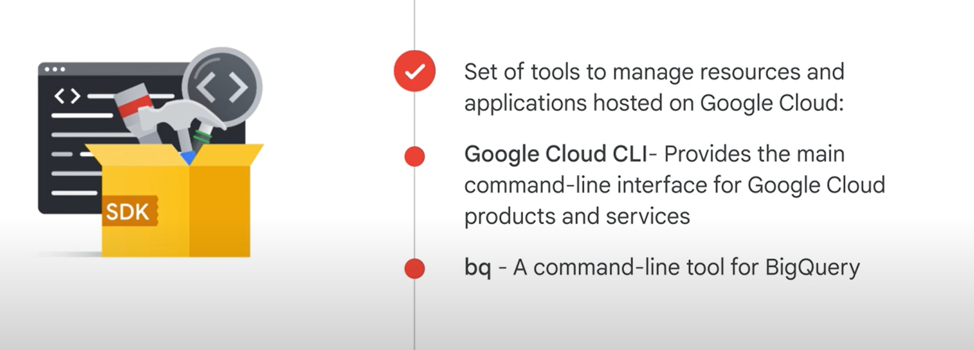

Shell:

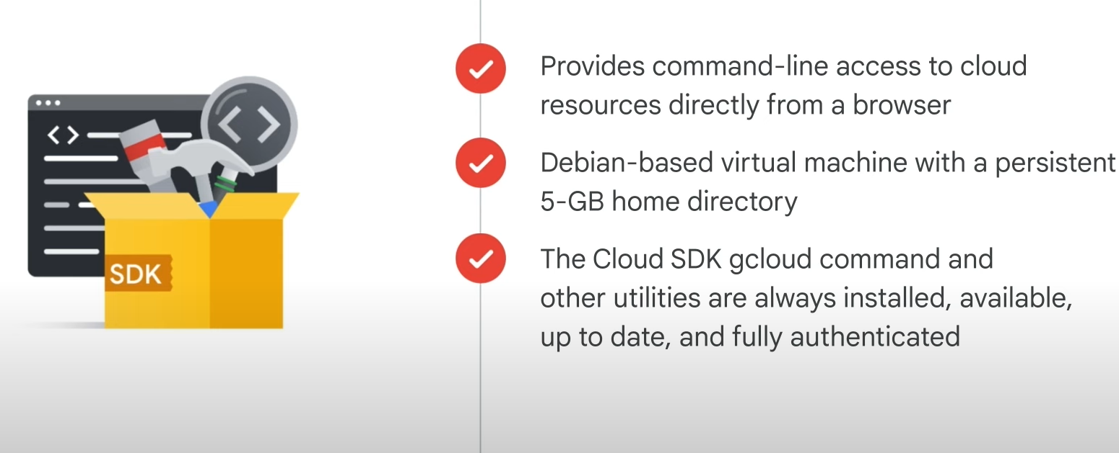

Api:

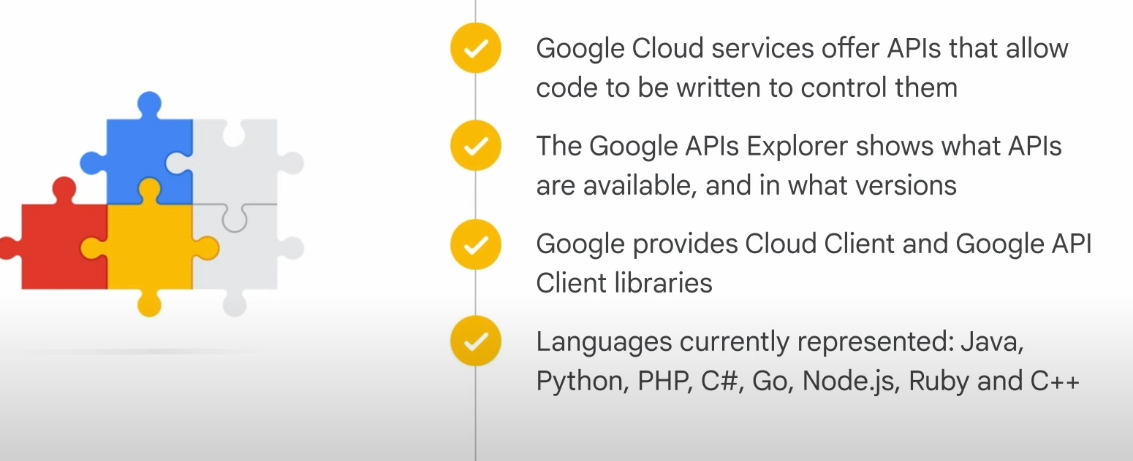

Cloud app:

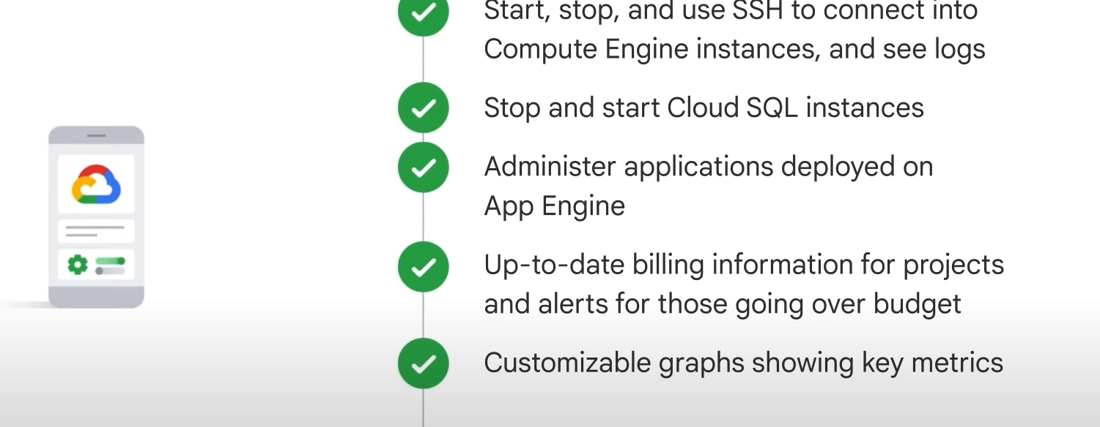

## Containers:

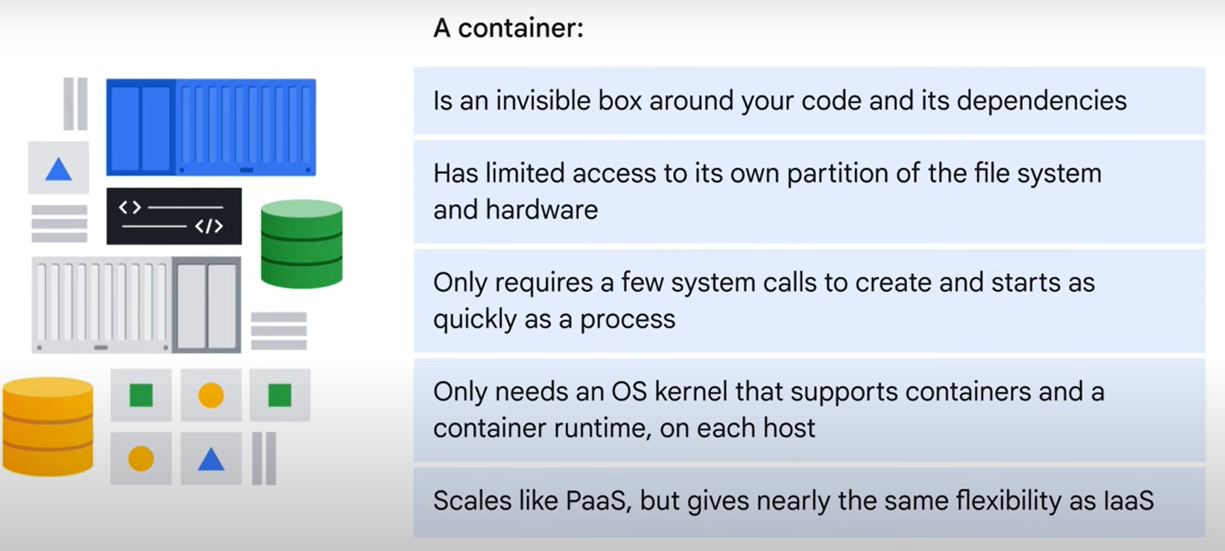

## Kubernetes:

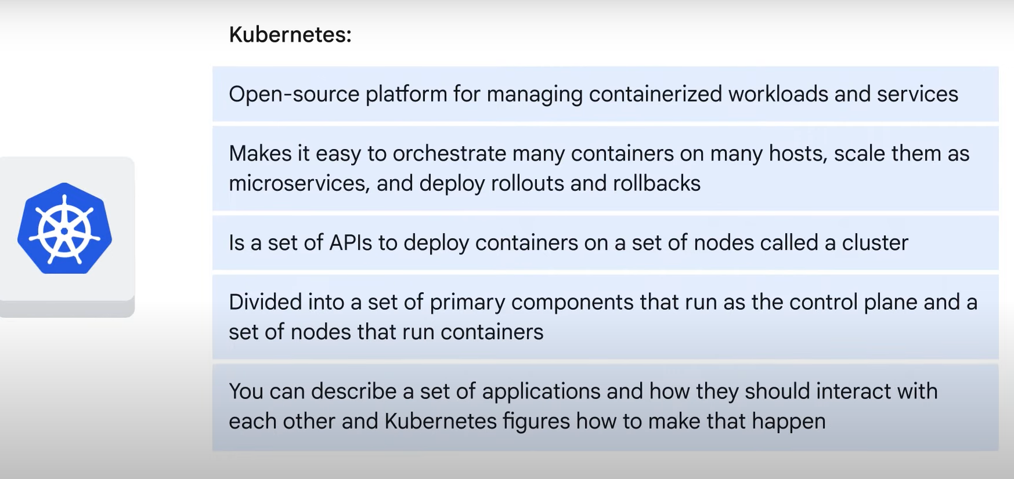

## Cloud run:

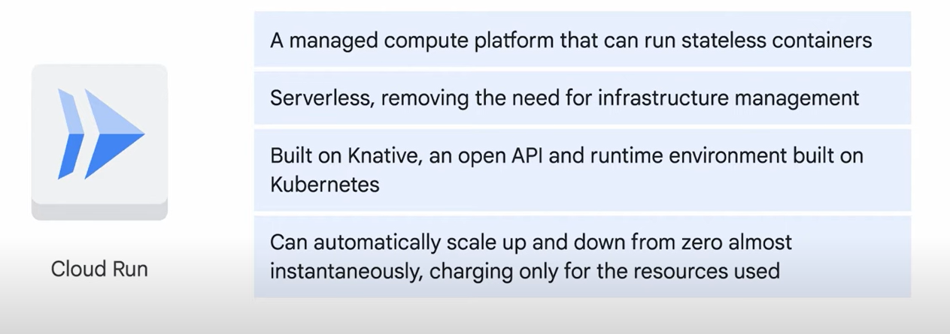

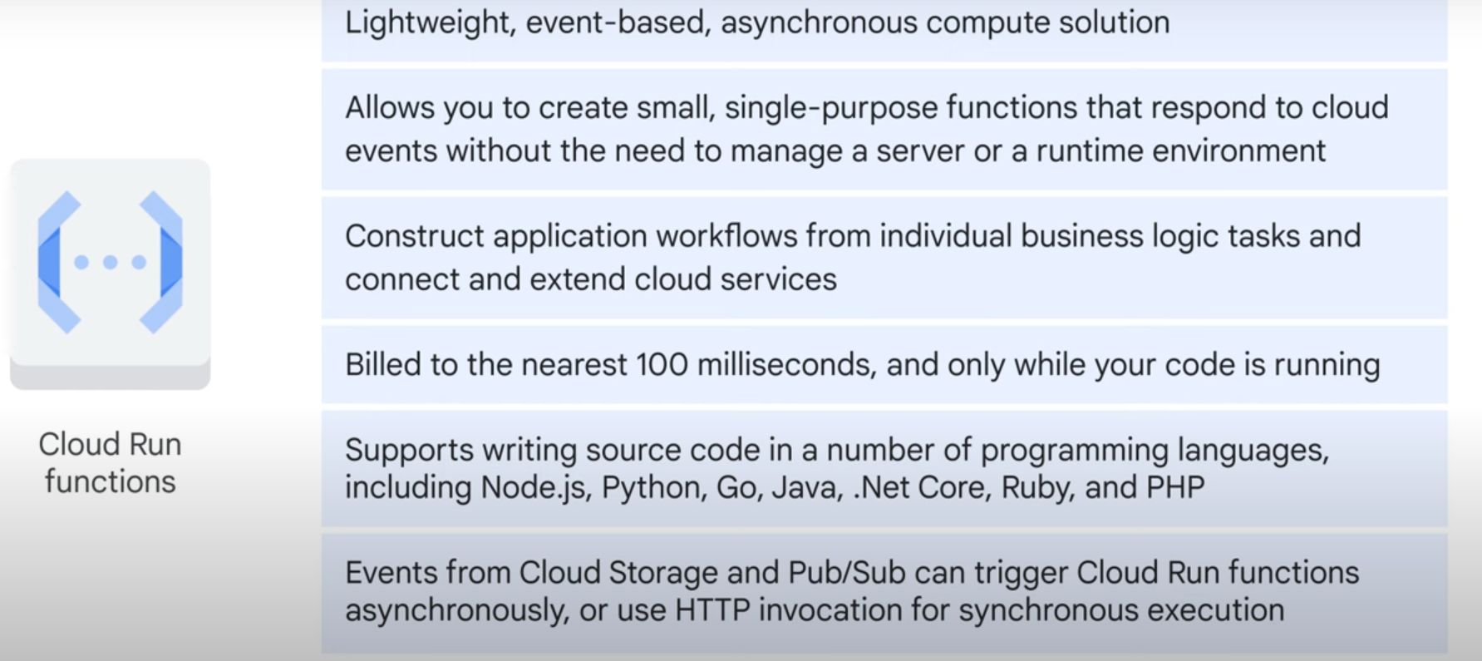

# Google Cloud Infrastructure: Foundation

# LAB

Google Cloud Console

Task 1. Deploy a web server VM instance

Task 2. Create a Cloud Storage bucket using the gcloud storage command line

Task 3. Create the Cloud SQL instance

1. In the Cloud Console, on the **Navigation menu** (), click **Cloud Storage > Buckets**.
2. Click **Create**.

**Task 1. Use Marketplace to build a deployment**

Navigate to **Marketplace**

1. In the Cloud Console, on the **Navigation menu** (), click **Marketplace**.
2. Locate the Jenkins deployment by searching for **Bitnami package for Jenkins**.
3. Click on the deployment and read about the service provided by the software.

**Launch Jenkins**

1. Click **Get Started**.
2. Verify the deployment, accept the terms and services and click **Agree**.
3. For the popup Successfully agreed to terms click **Deploy**.
4. Leave everything as default and click **Deploy** again.

Admin user - user

Admin password - Syk766moB.gY

**VPC Networking**

Verify that you cannot create a VM instance without a VPC network.

1. On the **Navigation menu**, click **Compute Engine > VM instances**.
2. Click **Create Instance**.
3. Accept the default values and click **Create**.

Notice the error.

1. Click **Advanced options**.
2. Click **Networking**. Notice the **No more networks available** error under **Network interfaces**.
3. Click **Cancel**.

**Note:**As expected, you cannot create a VM instance without a VPC network!

### **Create a VM instance in**us-east4

Create a VM instance in the us-east4 region. Selecting a region and zone determines the subnet and assigns the internal IP address from the subnet's IP address range.

1. On the **Navigation menu** (), click **Compute Engine** > **VM instances**.
2. Click **Create Instance**.
3. Specify the following, and leave the remaining settings as their defaults:

|  |  |
| --- | --- |
| **Property** | **Value (type value or select option as specified)** |
| Name | mynet-us-vm |
| Region | us-east4 |
| Zone | us-east4-a |
| Series | E2 |
| Machine type | e2-micro (2 vCPU, 1 core, 1 GB memory) |
| Boot disk | Debian GNU/Linux 12 (bookworm) |

1. Click **Create**.

### **Create the firewall rules for managementnet**

Create firewall rules to allow **SSH**, **ICMP**, and **RDP** ingress traffic to VM instances on the **managementnet** network.

1. In the Cloud Console, on the **Navigation menu** (), click **VPC network > Firewall**.
2. Click **Create Firewall Rule**.
3. Specify the following, and leave the remaining settings as their defaults:

|  |  |
| --- | --- |
| **Property** | **Value (type value or select option as specified)** |
| Name | managementnet-allow-icmp-ssh-rdp |
| Network | managementnet |
| Targets | All instances in the network |
| Source filter | IPv4 Ranges |
| Source IPv4 ranges | 0.0.0.0/0 |
| Protocols and ports | Specified protocols and ports |

**Note:**Make sure to include the **/0** in the **Source IPv4 ranges** to specify all networks.

1. Select **tcp** and specify ports **22** and **3389**.
2. Select **Other protocols** and specify **icmp** protocol.
3. Click **Equivalent Command line**.

### **Create a Cloud Storage bucket**

Create a Cloud Storage bucket to test access to Google APIs and services.

1. In the Cloud Console, on the **Navigation menu** (), click **Cloud Storage > Buckets**.
2. Click **Create**.
3. Specify the following, and leave the remaining settings as their defaults:

|  |  |
| --- | --- |
| **Property** | **Value (type value or select option as specified)** |
| Name | Enter a globally unique name |
| Location type | Multi-region |

1. Click **Create**. If prompted to enable public access prevention, ensure it is checked and cick **Confirm**. Note the name of your storage bucket.
2. Store the name of your bucket in an environment variable:

export MY_BUCKET=[enter your bucket name here]

Copied!

content_copy

1. Verify it with echo:

echo $MY_BUCKET

## Create a Windows virtual machine

### **Create a VM**

1. On the **Navigation menu** (), click **Compute Engine** > **VM instances**.
2. Click **Create instance**.
3. Specify the following, and leave the remaining settings as their defaults:

|  |  |
| --- | --- |
| **Property** | **Value (type value or select option as specified)** |
| **Name** | Type a name for your VM |
| **Region** | **us-east1** |
| **Zone** | **us-east1-d** |
| **Series** | **E2** |
| **Machine type** | **e2-standard-2(2 vCPUs, 8 GB memory)** |
| **Boot disk** | **Change** |
| **Public Images > Operating system** | **Windows Server** |
| **Version** | **Windows Server 2016 Datacenter Core** |
| **Boot disk type** | **SSD persistent disk** |
| **Size (GB)** | **64** |

1. Click **Select**.
2. For **Firewall**, enable **Allow HTTP traffic** and **Allow HTTPS traffic**.
3. Click **Create**.

## Create a custom virtual machine

### **Create a VM**

1. On the **Navigation menu** (), click **Compute Engine** > **VM instances**.
2. Click **Create instance**.
3. Specify the following, and leave the remaining settings as their defaults an then click **Select**.

|  |  |
| --- | --- |
| **Property** | **Value (type value or select option as specified)** |
| **Name** | Type a name for your VM |
| **Region** | **us-east1** |
| **Zone** | **us-east1-d** |
| **Series** | **E2** |
| **Machine type** | **Custom** |
| **Cores** | **2 vCPU** |
| **Memory** | **4 GB** |
| **Boot disk** | **Debian GNU/Linux 12 (bookworm)** |

1. Click **Create**.

### **Connect via SSH to your custom VM**

1. For the custom VM you just created, click **SSH**.
2. To see information about unused and used memory and swap space on your custom VM, run the following command:

free

Copied!

content_copy

1. To see details about the RAM installed on your VM, run the following command:

sudo dmidecode -t 17

Copied!

content_copy

1. To verify the number of processors, run the following command:

nproc

Copied!

content_copy

1. To see details about the CPUs installed on your VM, run the following command:

lscpu

Copied!

content_copy

1. To exit the SSH terminal, run the following command:

exit